**Improving LAN Bandwidth Based on Link Aggregation**

Student Version



Huawei Technologies Co., Ltd.

|  |
| --- |
| **Copyright © Huawei Technologies Co., Ltd. 2020. All rights reserved.**  No part of this document may be reproduced or transmitted in any form or by any means without prior written consent of Huawei Technologies Co., Ltd.  **Trademarks and Permissions**  HW_POS_RBG_Vertical-150ppi.png and other Huawei trademarks are trademarks of Huawei Technologies Co., Ltd.  All other trademarks and trade names mentioned in this document are the property of their respective holders.  **Notice**  The purchased products, services and features are stipulated by the contract made between Huawei and the customer. All or part of the products, services and features described in this document may not be within the purchase scope or the usage scope. Unless otherwise specified in the contract, all statements, information, and recommendations in this document are provided "AS IS" without warranties, guarantees or representations of any kind, either express or implied.  The information in this document is subject to change without notice. Every effort has been made in the preparation of this document to ensure accuracy of the contents, but all statements, information, and recommendations in this document do not constitute a warranty of any kind, express or implied. |

|  |  |
| --- | --- |
| Huawei Technologies Co., Ltd. | |
| Address: | Huawei Industrial Base  Bantian, Longgang  Shenzhen 518129  People's Republic of China |
| Website: | <https://e.huawei.com/> |

**Huawei Certification System**

Huawei Certification follows the "platform + ecosystem" development strategy, which is a new collaborative architecture of ICT infrastructure based on "Cloud-Pipe-Terminal". Huawei has set up a complete certification system consisting of three categories: ICT infrastructure certification, platform and service certification, and ICT vertical certification. It is the only certification system that covers all ICT technical fields in the industry. Huawei offers three levels of certification: Huawei Certified ICT Associate (HCIA), Huawei Certified ICT Professional (HCIP), and Huawei Certified ICT Expert (HCIE). Huawei Certification covers all ICT fields and adapts to the industry trend of ICT convergence. With its leading talent development system and certification standards, it is committed to fostering new ICT talent in the digital era, and building a sound ICT talent ecosystem.

Huawei Certified ICT Associate-Datacom (HCIA-Datacom) is designed for Huawei's frontline engineers and anyone who want to understand Huawei's datacom products and technologies. The HCIA-Datacom certification covers routing and switching principles, basic WLAN principles, network security basics, network management and O&M basics, SDN and programmability and automation basics.

The Huawei certification system introduces the industry, fosters innovation, and imparts cutting-edge datacom knowledge.

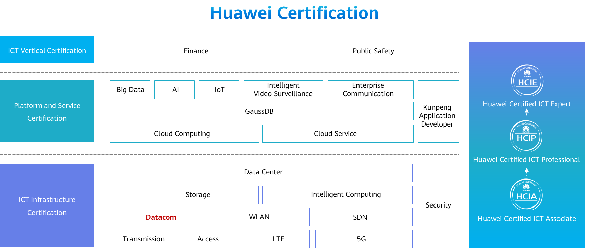

# Improving LAN Bandwidth Based on Link Aggregation

## Background

The company Jan16 uses two Layer 2 web-managed switches to set up a LAN. After the company has been operating for a certain period of time, a long delay and frame freezing often occur during communication between the two switches. The administrator needs to aggregate two GE links between the two switches to improve cascading bandwidth between the switches and achieve high network transmission quality.

The specific requirements are as follows:

1. The two switches SW1 and SW2 are connected through G0/0/1 and G0/0/2. Link aggregation is used to increase the cascading bandwidth of the switches.
2. The IP addresses of the PCs and interfaces of the switches are shown in the topology.

## Objectives

Upon completion of this task, you will be able to:

Learn how to add interface to E th-Trunk

Learn how to configure the logic E th-Trunk interface

## Topology

Network topology

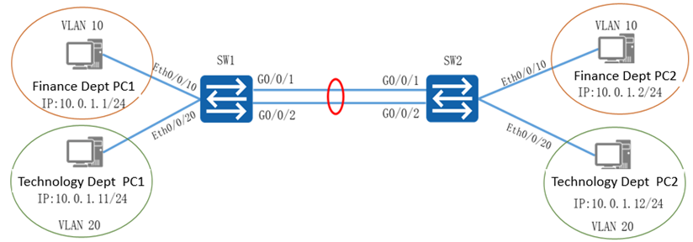

The VLAN planning, interface planning, and IP address planning can be referred in the appendix.

## Implementation

### Roadmap

1. Configure VLANs for departments.
2. Configure an aggregated link for the switches.
3. Configure IP addresses for PCs.

### Procedure

Configure VLANs on the switches.

#On SW1, create VLANs for departments and assign ports to the VLANs.

#On SW2, create VLANs for departments and assign ports to the VLANs.

Configure an aggregated link for the switches.

#On SW1, create Eth-Trunk 1, configure Eth-Trunk 1 to work in manual load balancing mode, and add interfaces to Eth-Trunk 1.

#On SW2, create Eth-Trunk 1, configure Eth-Trunk 1 to work in manual load balancing mode, and add interfaces to Eth-Trunk 1.

#On SW1, set the link type of ports in Eth-Trunk 1 to trunk and specify the allowed VLANs on Eth-Trunk 1.

#On SW2, set the link type of ports in Eth-Trunk 1 to trunk and specify the allowed VLANs on Eth-Trunk 1.

Configure IP addresses for PCs.

#Configure the IP address by referring to the appendix.

* 1. **Verification**

Check the VLAN configurations of SW1 and SW2.

#SW1

[SW1]display vlan

The total number of vlans is : 3

-------------------------------------------------------------------------------

U: Up; D: Down; TG: Tagged; UT: Untagged;

MP: Vlan-mapping; ST: Vlan-stacking;

#: ProtocolTransparent-vlan; \*: Management-vlan;

-------------------------------------------------------------------------------

VID Type Ports

-------------------------------------------------------------------------------

1 common UT:Eth0/0/1(D) Eth0/0/2(D) Eth0/0/3(D) Eth0/0/4(D)

Eth0/0/5(D) Eth0/0/6(D) Eth0/0/7(D) Eth0/0/8(D)

Eth0/0/9(D) Eth0/0/11(D) Eth0/0/12(D) Eth0/0/13(D)

Eth0/0/14(D) Eth0/0/15(D) Eth0/0/16(D) Eth0/0/17(D)

Eth0/0/18(D) Eth0/0/19(D) Eth0/0/21(D) Eth0/0/22(D)

Eth-Trunk1(U)

10 common UT:Eth0/0/10(U)

TG:Eth-Trunk1(U)

20 common UT:Eth0/0/20(U)

TG:Eth-Trunk1(U)

VID Status Property MAC-LRN Statistics Description

-------------------------------------------------------------------------------

1 enable default enable disable VLAN 0001

10 enable default enable disable Finance

20 enable default enable disable Technical

#SW2

[SW2]display vlan

The total number of vlans is : 3

-------------------------------------------------------------------------------

U: Up; D: Down; TG: Tagged; UT: Untagged;

MP: Vlan-mapping; ST: Vlan-stacking;

#: ProtocolTransparent-vlan; \*: Management-vlan;

-------------------------------------------------------------------------------

VID Type Ports

-------------------------------------------------------------------------------

1 common UT:Eth0/0/1(D) Eth0/0/2(D) Eth0/0/3(D) Eth0/0/4(D)

Eth0/0/5(D) Eth0/0/6(D) Eth0/0/7(D) Eth0/0/8(D)

Eth0/0/9(D) Eth0/0/11(D) Eth0/0/12(D) Eth0/0/13(D)

Eth0/0/14(D) Eth0/0/15(D) Eth0/0/16(D) Eth0/0/17(D)

Eth0/0/18(D) Eth0/0/19(D) Eth0/0/21(D) Eth0/0/22(D)

Eth-Trunk1(U)

10 common UT:Eth0/0/10(U)

20 common UT:Eth0/0/20(U)

VID Status Property MAC-LRN Statistics Description

-------------------------------------------------------------------------------

1 enable default enable disable VLAN 0001

10 enable default enable disable Finance

20 enable default enable disable Technical

Check the status of Eth-Trunk 1 on each switch.

#SW1

[SW1]display eth-trunk 1

Eth-Trunk1's state information is:

WorkingMode: NORMAL Hash arithmetic: According to SIP-XOR-DIP

Least Active-linknumber: 1 Max Bandwidth-affected-linknumber: 8

Operate status: up Number Of Up Port In Trunk: 2

-------------------------------------------------------------------------------

PortName Status Weight

GigabitEthernet0/0/1 Up 1

GigabitEthernet0/0/2 Up 1

#SW2

[SW2]display eth-trunk 1

Eth-Trunk1's state information is:

WorkingMode: NORMAL Hash arithmetic: According to SIP-XOR-DIP

Least Active-linknumber: 1 Max Bandwidth-affected-linknumber: 8

Operate status: up Number Of Up Port In Trunk: 2

-------------------------------------------------------------------------------

PortName Status Weight

GigabitEthernet0/0/1 Up 1

GigabitEthernet0/0/2 Up 1

Test the interoperability of PCs.

Run the **ping** command to test the internal communication of each department.

Ping PC2 in the finance department from PC1 in the finance department.

[C:\~]$ ping 10.0.1.2

Ping 10.0.1.2: 32 data bytes, Press Ctrl\_C to break

From 10.0.1.2: bytes=32 seq=1 ttl=128 time=63 ms

From 10.0.1.2: bytes=32 seq=2 ttl=128 time=62 ms

From 10.0.1.2: bytes=32 seq=3 ttl=128 time=47 ms

From 10.0.1.2: bytes=32 seq=4 ttl=128 time=47 ms

From 10.0.1.2: bytes=32 seq=5 ttl=128 time=47 ms

--- 10.0.1.2 ping statistics ---

5 packet(s) transmitted

5 packet(s) received

0.00% packet loss

round-trip min/avg/max = 47/53/63 ms

Ping PC2 in the technology department from PC1 in the finance department.

[C:\~]$ ping 10.0.1.12

Ping 10.0.1.12: 32 data bytes, Press Ctrl\_C to break

From 10.0.1.1: Destination host unreachable

From 10.0.1.1: Destination host unreachable

From 10.0.1.1: Destination host unreachable

From 10.0.1.1: Destination host unreachable

From 10.0.1.1: Destination host unreachable

--- 10.0.1.12 ping statistics ---

5 packet(s) transmitted

0 packet(s) received

100.00% packet loss

----**End**

## Appendix

The following tables show VLAN planning, interface planning, and IP address planning.

VLAN planning

|  |  |  |  |
| --- | --- | --- | --- |
| **VLAN ID** | **VLAN Naming** | **IP Address Segment** | **Purpose** |
| **VLAN 10** | Finance | 10.0.1.1-10/24 | Indicates the finance department. |
| **VLAN 20** | Technical | 10.0.1.11-20/24 | Indicates the technology department. |

Interface planning

| **Local Device** | **Port Number** | **Interface Type** | **VLAN** | **Peer Device** |
| --- | --- | --- | --- | --- |
| SW1 | Eth0/0/10 | access | VLAN 10 | PC1 in the finance department |
| SW1 | Eth0/0/20 | access | VLAN 20 | PC1 in the technology department |
| SW1 | G0/0/1 |  |  | SW2 |
| SW1 | G0/0/2 |  |  | SW2 |
| SW2 | Eth0/0/10 | access | VLAN 10 | PC2 in the finance department |
| SW2 | Eth0/0/20 | access | VLAN 20 | PC2 in the technology department |
| SW2 | G0/0/1 |  |  | SW1 |
| SW2 | G0/0/2 |  |  | SW1 |

IP address planning

|  |  |
| --- | --- |
| **PC** | **IP Address** |
| PC1 in the finance department | 10.0.1.1/24 |
| PC2 in the finance department | 10.0.1.2/24 |
| PC1 in the technology department | 10.0.1.11/24 |
| PC2 in the technology department | 10.0.1.12/24 |